

REGULATIONS MADE IN TERMS OF

Abattoir Industry Act 54 of 1976

section 8

General Regulations

RSA Government Notice R.93 of 1977

([RSA GG 5387](http://www.lac.org.na/laws/GGsa/rsagg5387.pdf))

came into force on date of publication: 28 January 1977

as amended by

RSA Government Notice R.625 of 1977 **(**[RSA GG 5516](http://www.lac.org.na/laws/GGsa/rsagg5516.pdf)**)**

**came into force on date of publication: 22 April 1977**

RSA Government Notice R.1122 of 1977 **(**[RSA GG 5607](http://www.lac.org.na/laws/GGsa/rsagg5607.pdf)**)**

**came into force on date of publication: 24 June 1977**

CONTENTS

*Regulations*

Definitions. . . . . . . . . . . . . . . . . . . . . . . . . . . . . . . . . . . . . . . . . . . . . . . . . . . . .1

*1. Definitions*

PART I

Meetings of the Commission . . . . . . . . . . . . . . . . . . . . . . . . . . . . . . . . . . . . . 2-10

2. *Calling of meetings*

3. *Postponement or cancellation of meetings*

4. *Agenda*

5. *Chairman’s participation in proceedings*

6. *Voting*

7. *Postponement or consideration of matters*

8. *Record of proceedings and minutes*

9. *Presence of persons other than members*

10. *Adjournment of meetings*

PART II

Applications under the Act . . . . . . . . . . . . . . . . . . . . . . . . . . . . . . . . . . . . . .11-17

11. *Application for erection of abattoir*

12. *Application for alteration of abattoir*

13. *Application for increase of tariffs of abattoirs*

14. *Objections to directions of an owner of an abattoir*

15. *Additional particulars may be required*

16. *Plans of abattoirs*

17. *Submission of documents to Minister*

PART III

Levies. . . . . . . . . . . . . . . . . . . . . . . . . . . . . . . . . . . . . . . . . . . . . . . . . . . . . . 18-21

18. *The period within which and the manner in which levies shall be paid*

19. *Certain facts to be proved in regard to condemn ed carcase*

20. *Recovery of certain levies paid on behalf of persons*

21. *Keeping of register*

22. *Offences and penalties*

ANNEXURES

ANNEXURE A: Application for approval to establish a new abattoir

ANNEXURE B: Notice of application for approval for the erection of a new abattoir in terms of section 12(1) of the Abattoir Industry Act, 1976 (No. 54 of 1976)

ANNEXURE C: Application for approval in respect of a proposed alteration to an abattoir

ANNEXURE D: Application for Approval for the Amendment of Abattoir Tariffs

ANNEXURE E1: Levy return: Abattoir owners

ANNEXURE E2: Levy return: Abattoir agents

ANNEXURE F: Register of daily slaughterings

DEFINITIONS

**1.** In these regulations, unless inconsistent with the context, a word or expression to which a meaning has been assigned in the Act, shall have a corresponding meaning, and -

“abattoir agent” means a commission agent dealing in the course of trade with meat and by-products derived from slaughter animals, excluding a hide and skin broker;

“application” an application in terms of Part II of these regulations;

“Chairman” includes the person designated under section 8(3) of the Act to act as chairman of the Commission;

“month” means the period from the first to the last day, both days inclusive, of any of the 12 months of the year:

“the Act” the Abattoir Industry Act, 1976 (No. 54 of 1976);

“week” means the period calculated from Monday to Sunday, both days inclusive.

PART I

MEETINGS OF THE COMMISSION

*Calling of meetings*

**2.** (1) The Chairman of the Commission shall convene a meeting of the Commission by notifying each member of the Commission, in writing, of the time, date and place at least seven days prior to the date of such meeting.

(2) Any such notification shall be accompanied by the agenda for that meeting and the draft minutes of the previous meeting (if available).

(3) The Chairman of the Commission may, notwithstanding the provisions of subregulations (1) and (2), convene a special meeting of the Commission at such shorter notice and in a manner he deems fit.

(4) Whenever any member of the Commission is unable to attend a meeting of which notice has been given. he shall, prior to the commencement of such meeting, inform the Chairman of the Commission of his inability to attend.

*Postponement or cancellation of meetings*

**3.** (1) The Chairman of the Commission may postpone or cancel any meeting of which notice has been given at any time prior to the commencement thereof.

(2) The Chairman of the Commission shall postpone or cancel a meeting of the Commission by notifying each member of the Commission of his decision in a manner he deems fit.

*Agenda*

**4.** (1) The matters which in the opinion of the Chairman of the Commission have to be dealt with at a meeting of the Commission, shall be listed on an agenda.

(2) The matters listed on the agenda of a meeting may be amended, supplemented or deleted by the Chairman of the Commission prior to the commencement of the meeting to which it relates, and by the Commission after such commencement.

(3) Unless the Chairman otherwise decides -

(a) no matter other than the matters listed on the agenda of a meeting shall be dealt with at that meeting;

(b) matters shall be dealt with in the order in which they are listed on the agenda

*Chairman’s participation in proceedings*

**5.** The Chairman of the Commission may participate from the chair in all proceedings at any meeting.

*Voting*

**6.** (1) A vote on a matter under consideration by the Commission shall be taken in a manner approved by the Chairman of the Commission.

(2) Subject to the provision of regulation 7, the Chairman of the Commission may, at any time during the consideration of a matter, suspend further discussions and demand a vote on such matter.

*Postponement or consideration of matters*

**7.** (1) The Commission may postpone the consideration or further consideration of a matter listed on the agenda or of a matter not so listed which is being considered by it in pursuance of a decision under regulation 4 (3).

(2) Any matter, the consideration or further consideration of which has been postponed under subregulation (1), shall at the discretion of the Chairman of the Commission be listed on the agenda of any later meeting of the Commission.

*Record of proceedings and minutes*

**8.** (1) A record of the proceedings of a meeting of the Commission shall be kept by an officer of the Department of Agricultural Economics and Marketing designated for that purpose by the Chairman of the Commission.

(2) Such record shall be kept in a manner approved by the Chairman of the Commission.

(3) Minutes shall be drafted in respect of each meeting of the Commission and submitted to the Commission for confirmation at any later meeting and if so confirmed, it shall be signed by the Chairman of the Commission.

(4) Minutes so confirmed by the Commission shall serve as prima facie evidence of the proceedings of the meeting concerned.

*Presence of persons other than members*

9. No person other than the members of the Commission may without the consent of the Chairman of the Commission -

(a) be present at any meeting of the Commission; and

(b) participate in any discussion at any such meeting.

*Adjournment of meetings*

10. A meeting of the Commission shall be adjourned by the Chairman of the Commission at his discretion.

PART II

APPLICATIONS UNDER THE ACT

*Application for erection of abattoir*

11. (1) Any application under section 11 of the Act for approval to erect an abattoir in a proclaimed area shall be made to the Minister on the form set out in Annexure A hereto.

(2) Notice of such application shall be given by the Minister publishing particulars thereof, in the form set out in Annexure B hereto, in the *Gazette* and in any registered newspaper circulating in the area in which it is intended to erect the abattoir.

(3) The notice referred to in subregulation (2) shall appear in the *Gazette* and in the newspaper concerned during the same week.

(4) The Minister may recover any costs incurred by him in regard to the publication of the notice referred to in subregulation (2) from the applicant concerned

[There is no full stop at the end of subregulation (4); there are no additional words.]

(5) Representations or objections by interested persons in connection with any such application shall be submitted to the Minister, in writing, and shall fully and clearly set out the grounds of such representations or objections.

(6) Whenever a person in terms of subregulation (5) submits to the Minister objections to an application, such person shall serve on the applicant a copy of the document in which such objections are set out.

(7) The applicant may submit to the Minister within 30 days after receipt of such copy or such longer period as may be approved by the Minister, a written answer to such objections.

(8) The Minister may, on considering such application, refuse to entertain the objections of any person who fails to comply with the provision of subregulation (6).

*Application for alteration of abattoir*

**12.** (1) Any application under section 13 of the Act for approval to substantially alter the layout of a proclaimed area, shall be made to the Minister on the form set out in Annexure C hereto.

(2) The Minister may in respect of any particular application, direct the applicant to give notice of such application in a specified manner and to request interested persons to submit to the Minister representations or objections in respect of such application within a specified period.

*Application for increase of tariffs of abattoirs*

**13.** (1) Any application under section 21 of the Act for an increase of a tariff in respect of the use of, or the performance of a service at, an abattoir shall be made to the Minister in the form set out in Annexure D hereto. Any application under section 21 of the Act for an increase of a tariff in respect of the use of, or the performance of a service at, an abattoir, shall be made to the Minister on the form set out in Annexure D hereto.

[subregulation (1) substituted by RSA GN R.625/1977]

(2) The provisions of regulation 12(2) shall *mutatis mutandis* apply to an application under subregulation (1).

*Objections to directions of an owner of an abattoir*

**14.** (1) Any person in respect of whom a direction issued to him by the owner of an abattoir in terms of section 32(2) of the Act applies, may lodge with the Minister a written objection to such direction within 30 days after the date which such direction was served on him.

[There is no full stop at the end of subregulation (1); there are no additional words.]

(2) Whenever a person lodges any such objection with the Minister under subregulation (1), such person shall serve on the owner concerned a copy of the document in which such objection is set out.

(3) Such owner may submit to the Minister within 10 days after receipt of such copy or any such longer period as may be approved by the Minister, a written answer to such objection.

(4) The Minister may refuse to entertain any such objection if the person concerned fails to comply with the provisions of subregulation (2).

*Additional particulars may be required*

**15.** (1) The Minister may, in connection with any application submitted to him, or any representations or objections relating to such application, require from the applicant or person who has submitted such representations or objections, as the case may be, such further particulars as may be determined by him.

(2) For the purpose of subregulation (1) the Minister may direct that such further particulars shall be submitted to him within a period determined by him.

(3) If the person from whom the Minister has required such further particulars, fails to submit it within the said period, the Minister may refuse to accord any further consideration to such application if such person is an applicant, or to entertain the representations or objections concerned on considering the application, if such person is a person who has submitted representations or objections in connection with such application.

[The word “it” should be “them”, to accord with the “particulars” referred to.]

(4) Unless the Minister otherwise directs the provisions of regulations 11(6) and (7) and 14(2) and (3), shall not apply in respect of the submission of such further particulars to the Minister.

*Plans of abattoirs*

**16.** (1) Where, under these regulations or in any annexure hereto, any requirement is made in regard to the submission to the Minister of a plan relating to an abattoir, such plan shall, when so submitted, be drawn in black waterproof ink on tracing linen or be a clear print on white cloth.

(2) A plan of the layout of an abattoir shall be to the scale of 1:250, or to any such other scale approved by the Commission and shall indicate -

(a) the scale concerned;

(b) the direction of true north;

(c) the dimensions and boundaries of the abattoir premises;

(d) the streets upon which the premises abut and the names thereof:

(e) the purposes for which the adjacent land is used;

(f) every entrance to the premises;

(g) every building, structure and other immovable improvements on the premises and purpose for which each is used;

(h) every entrance to such building, structure or other immovable improvement:

(i) the railway, road motor and truck off-loading and loading facilities;

(j) the situation of the premises in relation to existing or proposed main arterial roads.

(3) A plan of a building, structure or other immovable improvement shall be on a scale of 1:100 or to any such other scale approved by the Commission and shall indicate -

(a) the scale concerned;

(b) the direction of true north;

(c) every stoney or level separately in plan, elevation and cross section;

[The word “storey” is misspelt in the *Government Gazette,* as reproduced above.  
The word “cross-section” is normally hyphenated.]

(d) every room or area, the surface area thereof and the purpose for which each is used;

(e) all entrances, corridors, communicating doors and windows;

(f) all fixed equipment and the purposes for which it is used;

(g) the electricity, water and sewerage connection points.

(4) The Minister may, in respect of any particular application -

(a) exempt the applicant from the obligation to submit a plan to him, or from any requirement which a plan has to comply with in terms of this regulation;

(b) direct the applicant to bring on specific data on any plan which has been submitted to him;

(c) direct the applicant to submit to him, to the satisfaction of the Commission, any additional or separate plan in respect of any building, structure or other immovable improvement on the abattoir premises.

(5) The Minister may refuse to consider an application if the applicant fails to comply with the provisions of this regulation or with any direction issued thereunder.

*Submission of documents to Minister*

**17.** Representations, objections and other submissions in terms of these regulations, shall be affirmed under oath and submitted to the Minister in triplicate, by forwarding it under registered cover to the Chairman, Abattoir Commission, Private Bag X250, Pretoria, 0001, or by handing it in at the office of the said Chairman.

PART III

LEVIES

*The period within which and the manner in which levies shall be paid*

**18.** (1) A levy imposed by the Minister under section 28(1) of the Act on animals slaughtered -

(a) at an abattoir in the Republic where a scheme is not applied or at an abattoir in the Territory, shall be paid for the benefit of the Special Account, by the owner of the abattoir where such animals were slaughtered, under cover of a return on the form set out in Annexure E1 hereto on or before the 15th day of the month following the month in which the animals were so slaughtered;

(b) at an abattoir in the Republic where a scheme is applied, shall be paid for the benefit of the Special Account. by such abattoir agent, through whose agency those animals were slaughtered, under cover of a return on the form set out in Annexure E2 hereto on or before the Wednesday of the week following the week in which the animals were so slaughtered.

(2) For the purpose of subregulation (1) -

(a) payment of a levy in respect of animals slaughtered in the Republic, shall be made to the Meat Board, P.O. Box 1357, Pretoria, 0001, or at any branch office of the said Board, and in respect of animals slaughtered in the Territory, to the Meat Trade Control Board, P.O. Box 38, Windhoek, 9100;

(b) cheques and other negotiable documents shall be made payable to “the Meat Board”.

*Certain facts to be proved in regard to condemned carcase*

**19.** If in terms of section 28(3) of the Act it is determined that a levy shall not be payable in respect of any slaughtered animal of which the carcase has been condemned for human consumption by a competent authority in terms of any law, the return referred to in regulation 18(1)(a) or (b) shall be accompanied by a certificate of proof, to the satisfaction of the Minister. in respect of each carcase so condemned during the period to which such return relates.

*Recovery of certain levies paid on behalf of persons*

**20.** (1) Any owner of an abattoir who under regulation 18(1)(a) has paid or has to pay a levy for the benefit of the Special Account on an animal of which he was not the owner, may recover the amount of any such levy from the person on whose behalf the animal was slaughtered by adding it to the tariff payable to such owner under section 21 of the Act in respect of the slaughter of such animal.

(2) Any abattoir agent who under regulation 18(1)(b) has paid or has to pay a levy for the benefit of the Special Account on an animal which was slaughtered through his agency on behalf of any other person, may recover the amount of any such levy from such person by deducting it from the proceeds of the sale of the meat and by-products derived from such animal.

[There is no full stop at the end of subregulation (2); there are no additional words.]

*Keeping of register*

**21.** An owner of an abattoir shall establish and keep a register in the form set out in Annexure F hereto, in respect of the number of animals slaughtered daily at his abattoir.

*Offences and penalties*

**22.** Any person who fails to comply with the provisions of regulation 21 shall be guilty of an offence and on conviction be liable to a fine not exceeding R200 or to imprisonment for a period not exceeding 6 months.

[section 22 inserted by RSA GN R.1122/1977]

ANNEXURES

To view content without printing, scroll down.

To print at full scale (A4), double-click the icon below.





[Annexure D substituted by RSA GN R.625/1977]

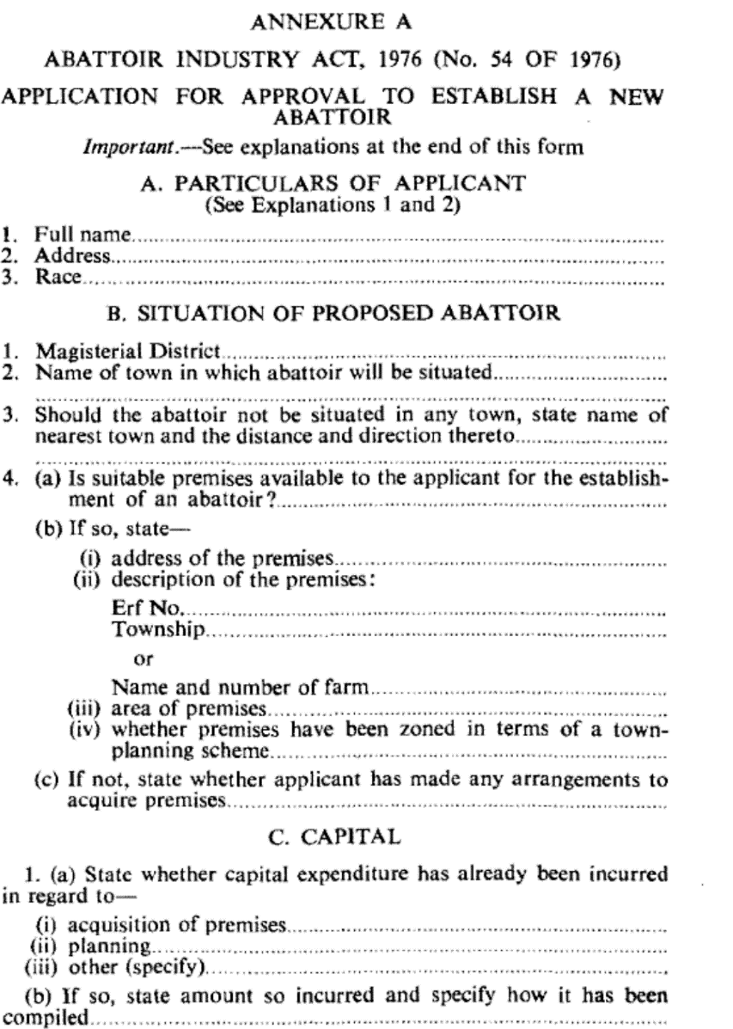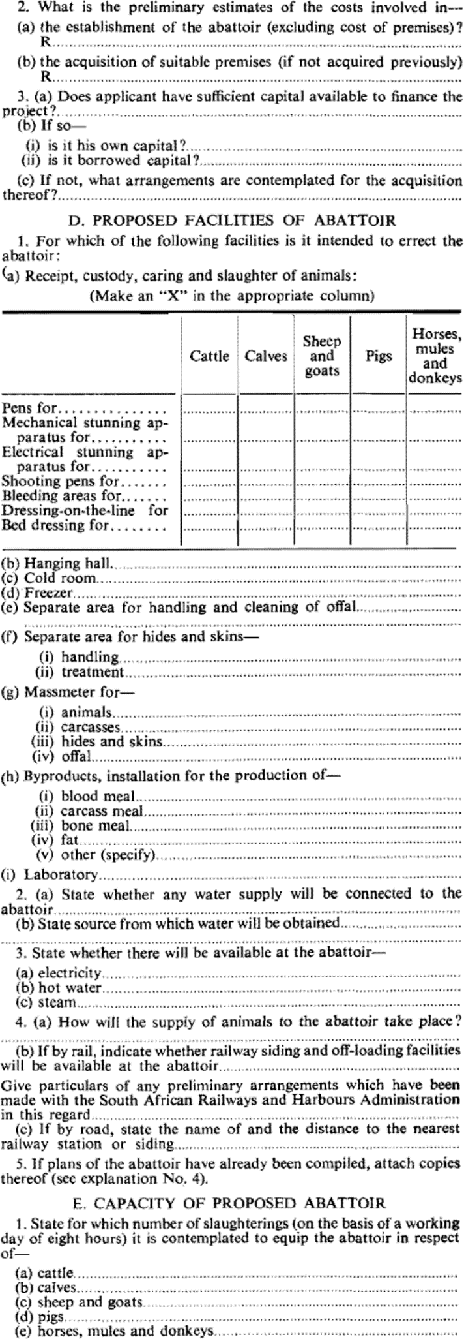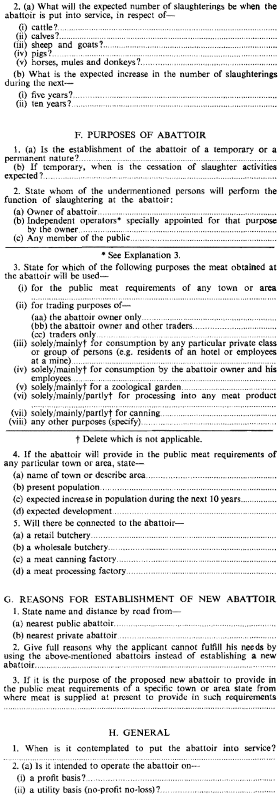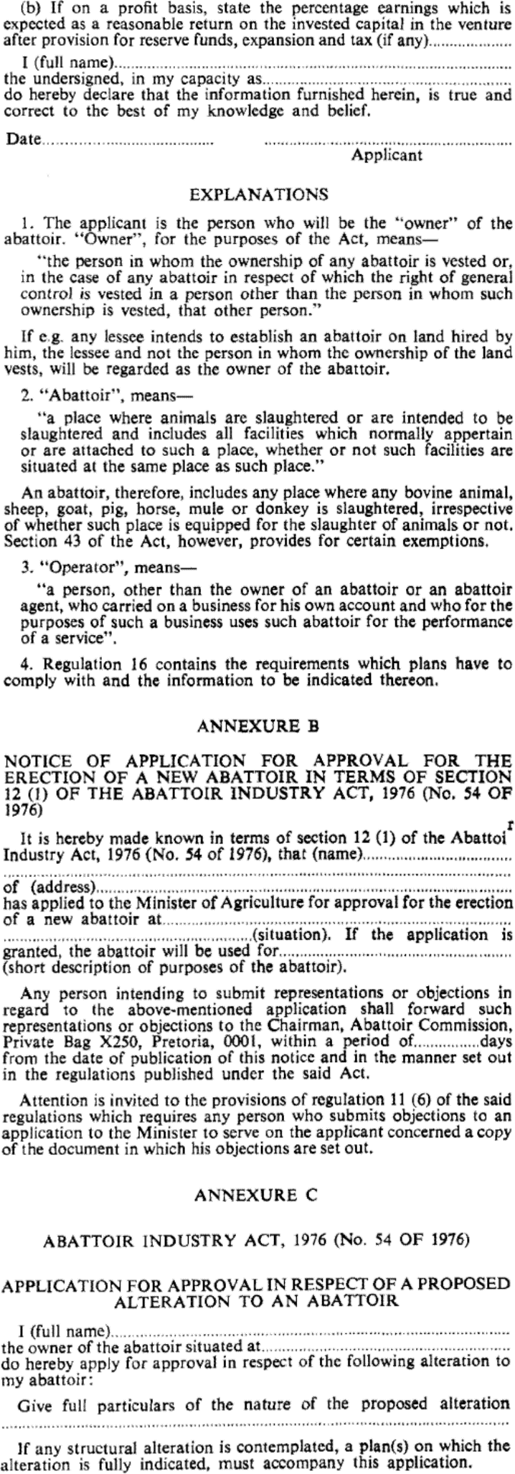

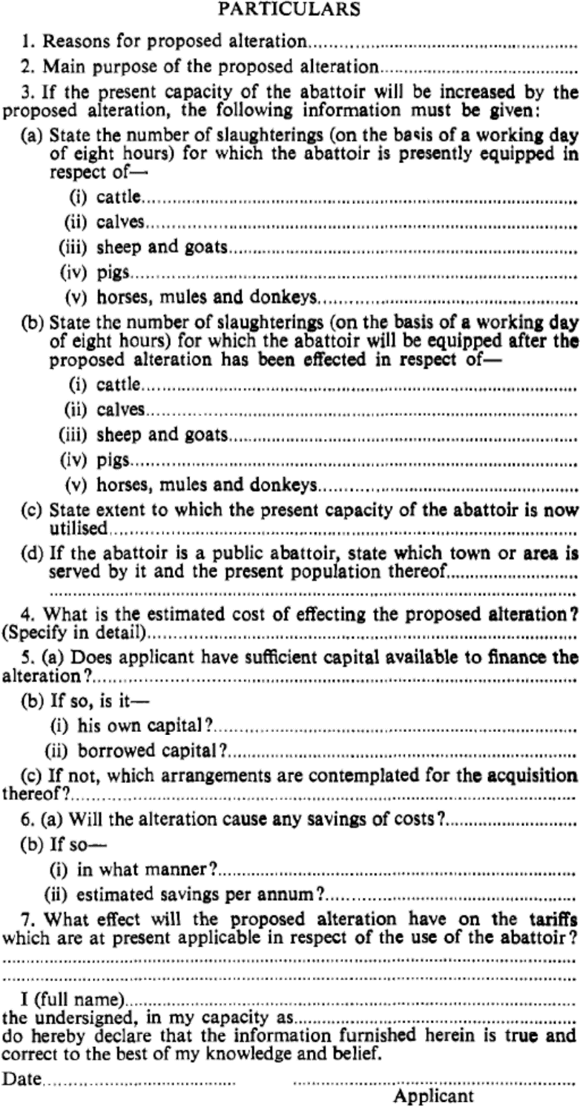

[Annexure D substituted by RSA GN R.625/1977]

